Microplastics determination and quantification in two benthic filter feeders Sabella spallanzanii, Polychaeta and Paraleucilla magna, Porifera
Giuseppe E. De Benedetto^{b} , Silvia Fraissinet^{a,*}, Nicoletta Tardioª , Sergio Rossiª, Cosimino Malitestaª
a Dipartimento di Scienze e Tecnologie Biologiche e Ambientali (DISTEBA), Universita` del Salento, Lecce, Italy
b Laboratorio di Spettrometria di Massa Analitica e Isotopica, Dipartimento di Beni Culturali, Universita` del Salento, Via Monteroni, 73100 Lecce, Italy
*Corresponding author: email address giuseppe.debenedetto@unisalento.it (Giuseppe E. De Benedetto) silvia.fraissinet@unisalento.it (Silvia Fraissinet)

Supplementary materials
Figure S1
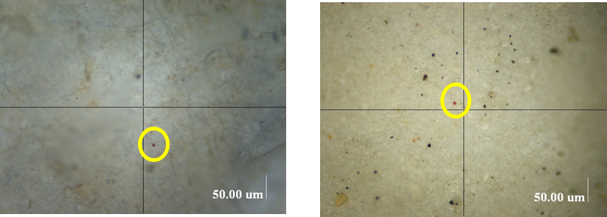
The red particles spiked in the sponges (a) and in the polychaetes (b) are easy to distinguish on the filter thanks to the quantitative digestion of the tissues and spiculae and chaetae.
b
a

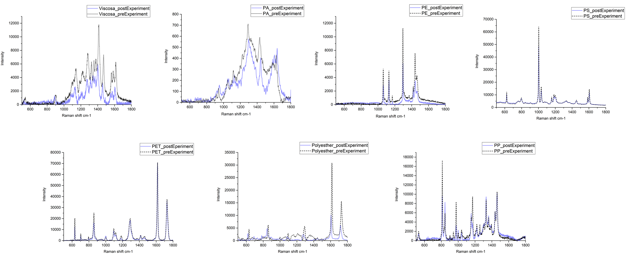
Figure S2 Raman spectra of microplastics, collected before (black dashed lines) and after (blue solid lines) treatment, demonstrating the chemical and spectroscopic stability of the tested polymers under the experimental conditions used to digest sponges and polychaetes.

Figure S3 Light microscope image of a blue fibre, approximately 5 µm in diameter, found in the sponge tissue digest. Scale bar 200 µm.
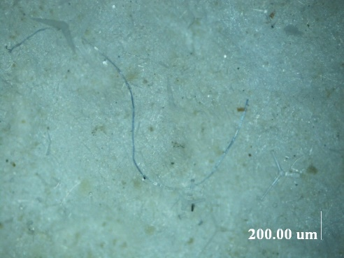

Table S1. Studies on MPs determination in Sponges and Polychates’s tissues.
Sponges
Species/genus | sampling | digestion method | %DE | authors
Carteriospongia;Ircinia;Tethyid | Organisms were sampled in the Indian Ocean, between 1 and 3 m depth | MPs contamination was evaluated performing histological analysis on sponges’ tissues. |  | Girard et al., 2021
Aplysina cauliformis; Amphimedon compressa; Callyspongia vaginalis; Ircinia campana; Mycale laevis; Niphates erecta. | Organisms were collected in the Panama Archipelago between 6 and 8 m depth | Digestion was performed by adding 5 – 10 mL of household bleach(Clorox, 6% sodium hypochlorite) to the samples, the procedure lasted 2 h at 60° C. |  | Fallon BR and Freeman CJ 2021
H. implexiformis; A. atlantica;H. implexiformis; H. melanadocia | Organisms were sampled in the Gulf of Mexico in two different sites (disturbed and undisturbed areas), 50 m from the coastline, at 1.30 m depth. | From each sponge, a subsample was collected and introduced into a solution prepared with distilled water, hydrogen peroxide, and ammonium hydroxide in equal parts; the solution was left to act at 50 °C for 3 days. |  | Celis-Hernandez et al., 2021
Agelas conifera | Sampling took place on Pramuka Island, Seribu Islands, in March 2021, was performed at each station using 3 line transects. The saamples were coolected at 0 m, 30 m, and 50 m on each line transect. | 10 gram of sponge tissue was treated with 10% KOH until the sample  was submerged, the samples were left for 24 hours. Then NaCl solution was added to the tissues and incubated again for 24 hours. |  | Sari et al., 2023
not reported | A large sponge specimen was collected in July 2019 in the Portoﬁno Marine Protected Area at 10 m depth | A subsample was chemically digested following multiple steps:  Step 1 Digestion: An aliquot of samples was digested in 10% KOH (25mL)solution for 24 h at 60 °C, under constant agitation (150 rpm).  Step 2 Density separation: after digestion, the digested samples were filtered on glass ﬁber ﬁlters and were added to a brine solution of ZnCl₂ density (1.6 g cm⁻³). The mixture was agitated and then left to set. The complete settling took 20 min. Then the supernatant was ﬁltered.  Step 3 Isolation of larger microplastics (>25 μm): the supernatant from previous step was ﬁltered on 25 μm mesh size filters Step 4 isIolation of the smaller microplastics (<25 μm): the filtered solution from the previous step was neutralized with HCl 2 M, and then ﬁltered (Whatman GF/D 0.2 μm).  Step 5 Pressurized Solvent Extraction (PSE): the filters resulted from Step 4 underwent to PSE. The extracts were dried and placed into the pyrolysis cups for the subsequent Py-GC-MS analysis. |  | Saliu et al., 2022
not reported | Some fragments and/or entire organisms were selected from the Cantabrian Sea Maritime Museum: the samples were collected in the Southern Gulf of Biscay between 0 and 23.5 m depth and are part of the 1996 and 1999 museum collections | Sponges tissues were manually cut and a visual inspection for MPs research was performed.. |  | Modica et al., 2020
-At Mahanga Bay. Crella incrustans, Suberites australiensis, and Dactylia varia  - At Shark Bay, Crella incrustans, Suberites australiensis, and Chondropsis sp.  - Aat Evans Bay Crella incrustans, Crella affinis, and Halichondria knowltoni | Sponges fragments (2 to 5 cm³ approx) were collecred at three sites in the harbour: Mahanga Bay Shark Bay and Evans Bay in April 2022. Samples were collected via SCUBA diving operators between 2 and 11 m depth. | Samples were weighed and stored in glass vials, then 10 mL of household bleach (6% sodium hypochlorite, NaCl) was added to each sample. All samples were agitated manually for 30 seconds and left for 48 hours to dissolve at room temperature. Samples were shaken again after 24 h for additional 30 s and other 5 mL of bleach were added. |  | Parry et al., 2023
Hymenacidon perlevis | Samples were collected in April 2014 and stored in ethanol. The samples were pooled, weighed, and stored at -20° C for 2h and then desiccated in a freeze dryer for 48h. | Samples were digested using a microwave. 0.2g of samples were introduced to each vessel with 5mL of MilliQ water and 5mL of HNO₃ (65%) and a preprogrammed digestion program was performed. Than 1mL concentrated H₂O₂ (> 30%) was added to the samples for a second digestion program. After digestion 30 mL MilliQ and 10 mL NaOH (2 M) was added to the vessels to neutralize the solution prior filtration. Moreover an additional density separation step was performed directly into the vessels to separate silica spiculae. The samples were then filtered and filters were rinsed with 30 mL of H₂O₂ (30%). |  | Karlsson et al., 2017
C. reniformis, I. variabilis, P. ficiformis,  and S. spinosulus | The sponges were collected along the Moroccan Mediterranean coast, in four sampling sites. SCUBA diving operators took the animals at a 1-15m depth during summer 2020. | Samples were digested used a ptent method by Ferrante et al., 2020:  nitric acid 65% is added to the samples and the mineralization took placel at 60 °C for 24 h. Then, 3 ml ultrapure water and 9 ml of dichloromethane were added to each sample, vortexed for 15 minutes. After reagents evaporation each sample was again extracted using 9 ml of dichloromethane. Samples were then dried and re susoended with 200 µl of acetonitrile. |  | Kirchek et al., 2023
Cinachyrella alloclada | The samples are from Profiera collection of the Bahia Natural History Museum (MHNBA). Twenty sponges in total were analysed from the intertidal reef in Pituba beach, Salvador city, Brazil. Ten specimens were from the 1981 collection and ten specimens were from the 2017 collection. All the organisms were preserved in glass jars filled with 80% ethanol. | Sponges fragments were cut using metal tools and the microplastic research was performed by visual analysis (following Modica et al., 2020). |  | Soares et al., 2022
P. magna. | Samples were collected in the Mariculture Mar Grande, in the Mar Grande of Taranto, (Ionian Sea) Apulian, Italy | The whole organism was digested using a first alkaline step with 20 mL 5% KOH, 10% H₂O₂, placing the bottles at 75 °C for 3 h. Then a centrifugation to separate the supernatant from the sponges’ spiculae was performed. After centrifugation, an acidic step with a solution of formic acid (25%) and sodium citrate (10%) was performed. 5mL of the acidic solution was added to the residue and left for 15 minutes, both solutions were filtered on the same filter. | 98% | Present work

Polychaetas
Species/genus | sampling | digestion method | %DE | authors
Sabella spallanzanii | Samples were collected in three Italian harbors (Ostia, Santa Marinella, and Torre del Sale) in the Central and Northern Tyrrhenian Sea. | Organisms were extracted from the tubes; three different protocols (P) were tested to digest the whole animal body.  P1) samples were treated with 10% potassium hydroxide (KOH) solution at 60 °C for 12h. The added volume was equal to 3 times the tissue volume.  P2) samples were treated with 15 ml of 15% hydrogen peroxide (H₂O₂) for each gram of tissue at 50 °C for 12h  P3) the same solution of the P1 was tested here keeping samples at room temperature for 2–3 weeks. | P1) 90% P2) 96% P3) 96% | Vecchi et al., 2021
Sabella spallanzanii | Samples were collected in the Northern, Central, and Southern Adriatic Seas during the summer of 2016 by scuba diver operators | Samples were dried at 60 °C for 24 h and crushed. The extraction protocol started with density-separation step with a NaCl hypersaline solution (density 1.2 g cm³), then the solution was filtered and partial digested hydrogen peroxide (15%) |  | Avio et al., 2020
Sabella pavonina | Samples were collected in the inner Oslo fjord, Norway during May and September 2017. | All samples were treated with 10% KOH solution overnight, at 50 °C. After digestion, 100 ml of NaCl hypersaline solution (d 1.2 g/cm³) was added to each sample, stirred for 10 min, and decanted for 10 min, then the supernatant was collected. The density separation step was performed twice, and the resulting supernatant was filtered on 8 µm pore size filters. |  | Bour et al., 2018
Diopatra sp.; Lumbriconereis sp.; Ancistrosyllis sp.; Dendronereis sp.; Nereis sp. and Ceratonereis sp. | The sampling was performed in Kochi (southwest coast, of India), along the near-shore (5 m depth) during the dry (March and May) and wet (July and September) seasons of the 2019. | In the lab each polychaeta was gently removed from its tube. Tissues were placed in glass baekers and digested using KOH (10%) solution at 60 °C overnight. |  | James et al., 2023
Galathowenia oculata; Galathowenia  fragili and Owenia borealis | Sampling operations were carried out in 2017 at the Norwegian Continental Shelf. | After drying the samples at 60 °C overnight, a two step digestion procedure was performed:  - A mixture of 8% NaOH, 6.5% thio-urea and 8% urea in water was added to the samples, that were than stored at -20 °C for 40 minutes.  - 30% H₂O₂ and 1% NaOH solution was added to the samples for the oxidative step. |  | Knutsen et al., 2020
Arenicola marina | Specimens were collected in 6 stations along the Belgian, Dutch; and French coastline in the intertidal zone in the late summer of 2011 | The animals’ tissues were digested using 69% HNO₃ and left overnight. The day after the solution was left boiling and dilution (1:10 v/v) with warm (~80 C) FDW for 2 h. |  | Van Cawenbergh et al., 2015
Polychaetes | Samples were collected seasonally in Jiaozhou Bay between December 2018 and September 2019. All the samples were stored in 5% formaldehyde in jars at room temperature. | The soft part of the organisms were digested with 10% KOH in an oscillating incubator water bath at 60° C until completely digested. |  | Zhang et al., 2023
Namalycastis sp | Samples were collected by hand in six stations within the Setiu Wetlands, Malaysia between November 2016 and November 2017. | Samples were digested for 48 h at 60 °C until completely dissolved using a solution of 10 M NaOH. |  | Hamzah et al., 2021
Hediste diversicolor | Samples of the same size were manually collected (upper 20 cm depth) then rinsed to remove external sediment. | The organism’s soft tissues were pooled. Approximately 10g fresh tissue of each was treated with KOH 10% and heated at 60 °C under continuous agitation for 24 h. The obtained solution was treated with potassium iodide (KI) 50%. |  | Missawi et al., 2020
Phragmatopoma caudata |  | 15 g of samples were treated with 40 ml of KOH 10%, at 60 °C for 48 h. The vials were manually agitated every 2 h, and between 8 and 18 h. |  | Barcellos da Costa et al 2021
Sabella spallanzanii | Samples were collected in the Mariculture Mar Grande, in the Mar Grande of Taranto, (Ionian Sea) Apulian, Italy | The animals were gently removed from the tubes and digested using a first alkaline step with 20 mL 5% KOH, and 10% H₂O₂, bottles were placed at 75 °C for 3 h. After digestion a centrifugation step was performed, and the supernatant was removed. Then 5mL of a solution of formic acid (25%) and sodium citrate (10%) was added to the residue to dissolve chaetae and left for 15 minutes. Both solutions were filtered on the same filter | 99% | Present work

