Supplementary Material
Disposable electrochemical sensor based on ion imprinted polymeric receptor for Cd(II) ions monitoring in waters

Marco Costa¹, Sabrina Di Masi^{1*}, Alvaro Garcia-Cruz², Sergey A. Piletsky², Cosimino Malitesta¹
¹Laboratorio di Chimica Analitica, Edificio A6, Università del Salento, Via per Monteroni 73100, Lecce (Italia)
²Department of Chemistry, University of Leicester, University Rd LE1 7RH, Leicester (UK)
*corresponding author: Sabrina Di Masi, sabrina.dimasi@unisalento.it

Scheme 1: Schematic diagram of electrochemical process and Cd(II) interaction
The electrochemical process involved in polymeric synthesis in the presence of the target ion (Cd(II) ions) may be described as reported in the following scheme (Scheme S1). Possibly, binding interaction between both the functionalities of the functional monomer (amine and carboxylic groups) and Cd(II) ions are responsible for Cd(II) complexation and the analyte sensing during rebinding. The amine groups can be responsible also for polymeric layer growth. At the same time, the carboxylic groups can be easily used in binding purposes via weak hydrogen bonds with the target analyte.
Scheme S1. Schematic diagram of the electrosynthesis process and target interactions.
Section 1. Optimisation of sensor development
Table S1. Details of the selected independent variables for the optimisation studies.

Independent variables | -1 | 0 | +1
Cd(II) concentration (mmol L¹), X₁ | 2.1 | 6.3 | 10.5
Number of CV scans, X₂ | 10 | 25 | 40
Elution time (min), X₃ | 10 | 35 | 60

Section 2. Electrochemical characterisation
Electrochemical impedance spectroscopy: Randles equivalent circuit
EIS data were represented by Nyquist plots and consisted of a high-frequency semicircle and straight line at low-frequency range. The semicircle portion reflects the electron transfer kinetics, while the straight line represents the diffusion of the redox molecules from the bulk solution to the electrode surface. The circuit elements include a charge transfer resistance in series with Warburg impedance to represent the solution resistance and the diffusion part, respectively, and in parallel the constant phase element (instead of double layer capacitance) because of the non-uniform distribution of capacitance over the electrode surface.
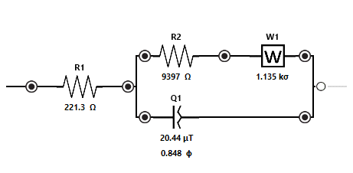
Figure S1. Randles equivalent circuit used for EIS data fitting and interpretation.
Section 3. Cd(II) ion sensing and binding isotherms
Temkin isotherm model

The IIP sensor revealed the proportional dependence of the achieved Δi with the adsorbed Cd(II) ions (C_{ads}) according to the follow equation: (Eq. S1):
$$Eq. S1, ∆i=kC_{ads}$$

Where “k” is a constant. By calling “θ” as the ratio between the adsorbed Cd(II) concentration on the electrode and the maximum Cd(II) ion concentration that can be absorbed: $θ=\frac{C_{ads}}{C_{max}}$

Thus, the Eq. S1 can be rewritten as follow: $∆i=kC_{max}*θ$ and based on the rearrangement of Temkin isotherm model, it can be observed the logarithmic dependence between the current responses and Cd(II) ions concentration (Eq. S2):

$$θ=\frac{RT}{b}2.303\log\left(K\left[Cd\left(II\right)\right]\right)=\frac{RT}{b}2.303logK+\frac{RT}{b}2.303log\left[Cd\left(II\right)\right]$$

If, $Eq. S2, A=\frac{RT}{b}2.303$

$θ=A*logK+A*log[Cd\left(II\right)]$

Where A is the constant related to the heat of adsorption, which include the term relative to the Temkin constant (b). Therefore, the final equation that express the logarithmic dependence of the Cd(II) concentration to the current response is displayed in (Eq. S3)

$$∆i=kC_{max}A*logK+kC_{max}A*log⁡[Cd\left(II\right)]$$

If , $B=kC_{max}*A$

$$Eq. S3, ∆i=B*logK+B*log⁡[Cd\left(II\right)]$$

Where K is the association constant (nmol L⁻¹).

Section 4. Optimisation of sensor performances
Table S2. Matrix reporting the experimental runs and Y responses for each analysed point.

Cd(II) concentration | Number of CV cycles | Elution time (NaOH, 0.25 M) | Y (Sensitivity of Cd(II)-IIP film)
2.1 | 10 | 10 | 0.749687987
10.5 | 10 | 10 | 0.683724155
2.1 | 40 | 10 | 0.678611123
10.5 | 40 | 10 | 0.690071853
2.1 | 10 | 60 | 0.997560017
10.5 | 10 | 60 | 0.909377816
2.1 | 40 | 60 | 0.841070888
10.5 | 40 | 60 | 1.098253156
2.1 | 25 | 35 | 0.877471981
10.5 | 25 | 35 | 1.008777532
6.3 | 10 | 35 | 0.675785829
6.3 | 40 | 35 | 0.711083237
6.3 | 25 | 10 | 0.697707487
6.3 | 25 | 60 | 1.135081385
6.3 | 25 | 35 | 0.909377816
6.3 | 25 | 35 | 0.850087604
6.3 | 25 | 35 | 0.930614428

Response surface regression
Minitab (v. 18) software was used to obtain the response surface regression. The equation (Eq. S4) was obtained:
Eq. S4
$$Y=0.63-0.0549 X_{1}+0.077X_{2}-0.001 X_{3}+0.004 {X_{1}}^{2}-0.0007 {X_{2}}^{2} +0.00007 {X_{3}}^{2}+0.0008 X_{1}X_{2}+0.0002 X_{1}X_{3}+0.00003 X_{2}X_{3}$$

Where X₁ was the concentration of Cd(II) ions, X₂ was the CV cycles during electropolymerisation and X₃ was the time of elution time by incubation in NaOH 0.25 M.

The equation reported the significant factors affecting the Y response, which was the sensitivity of Cd(II)-IIP film towards Cd(II) ions in the range of concentration between 10 and 640 nmol L⁻¹. These standardised effects on the Y response are presented in the Pareto Chart as shown Figure S2. Pareto chart demonstrated that CV scan cycles and Cd(II) concentration are the remarkably significant factors affecting the sensitivities of Cd(II)-IIP films.

Figure S2. Pareto Chart of the Standardised effects

Figure S3 shows the main effect plot on the response.

Table S3. Model summary of fit.
S | R-sq | R-sq(adj) | R-sq(pred)
0.0671800 | 91.46% | 80.47% | 0.82%

Figure S4. Optimisation plot.

Section 5. Characterisation of Cd(II)-IIP film and NIP films
The morphological analysis by SEM of Cd(II)-IIP film, NIP film vs bare SPCE was elucidated in Figure S5.
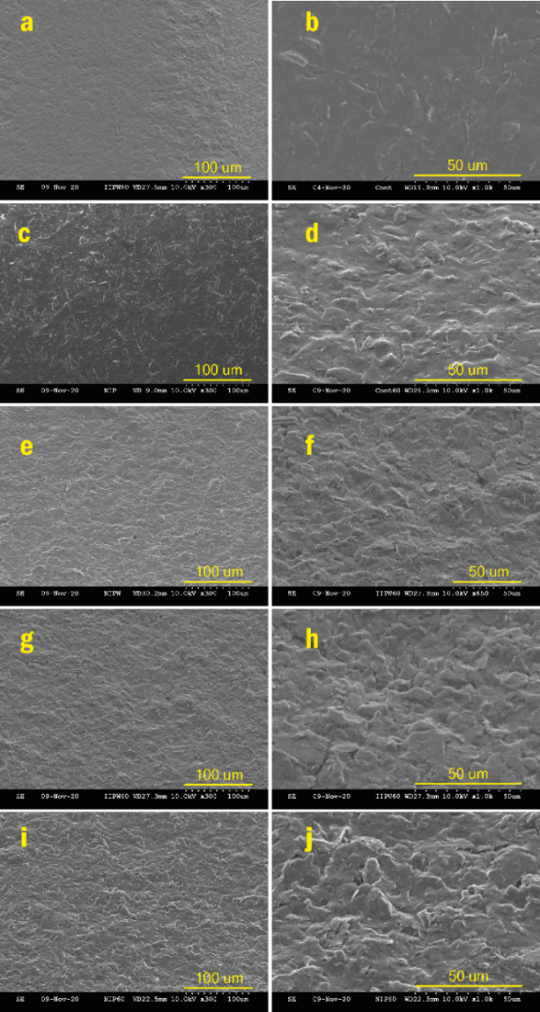
Figure S5. Bare SPCE (a-b), non-imprinted polymer (NIP) before (c-d) and after (e-f) washing. The ion imprinted polymer (IIP) before (g-h) and after (i-j) washing.

A | B
Figure S6. ATR-FTIR measurement for (A) Cd(II)-IIP films after polymerisation and after wash treatment in NaOH 0.25 mol L⁻¹.(B) NIP films after polymerisation and after wash treatment in NaOH 0.25 mol L⁻¹.

Section 6. Reproducibility, and stability tests

Figure S7. (A) Working life of Cd(II)-IIP film exposed to 320 nmol L⁻¹ of Cd(II) ions dissolved into sodium acetate buffer (50 mM, pH = 5.0) during 180 minutes of experiments. Each value was the average of current peaks from 20 CV cycles subtracted from CV of blank solution. (B) Reproducibility measured by the comparison of different sensors (5) exposed to 160 nmol L⁻¹ of Cd(II) ions.

Section 7. Selectivity test on NIP film
Selectivity tests were also carried out in the case of NIP films.
Figure S8. Selectivity studies on NIP film towards potential interfering ions at the concentration of 320 nmol L⁻¹.
NIP film responses have been compared with that for Cd(II)-IIP film against the target ion (Cd(II) ions) and other potential interferents (Fig. S8). As result, NIP film exhibited more affinities towards Ag(I), Mn(II), Co(II), and Cu(II) ions, which remained quite lower than the respective cross-reactivities of Cd(II)-IIP films.

